REITube
Specifications
Contents
1. INTRODUCTION 3
1.1. Purpose 3
1.2. Project Background 3
2. SPECIFICATIONS 4
2.1. Hardware 4
2.2. Dashboard 4
2.2.1 Date & Time widget 5
2.2.2 Weather widget 5
2.2.3 Tags widget 5
2.2.4 Like widget 5
2.2.5 Description widget 6
2.3. YouTube Videos 6
2.4. Video Queue 6
2.5. Access 6
2.6. Stored Metadata 6
2.7. Video Trimming 7
2.8. Volume levels 7
2.9. Tagging 7
2.10. Liking videos and feedback 8
3. PROCESS 9
3.1. Submission Process 9
3.2. Review Process 9
4. FUTURE ENHANCEMENTS 10
Figures
Figure 1: REITube Dashboard 5
Tables
Table 1: REITube Metadata 7
Table 2: Future Enhancements 10

Appendix Table 1: Table of Tabled Ideas 11

Document Version History
Version # | Author(s) | Revision Date | Reason
1.0.0 | Sarah Florer | 8/30/13 | Initial draft
1.0.1 | Christian Manalansan | 9/4/13 | Updates

INTRODUCTION

Purpose
The purpose of this document is to present the specifications and process for the REITube project.

Project Background
The TVs in the upstairs atrium and the cafeteria, two locations where many employees eat lunch or hang out, currently show CNN. Repetitive news is neither exciting nor engaging.
Research shows that looking at funny or happy videos can make people think more creatively and that looking at pictures of cute animals makes people more productive. To capitalize on this, the REI Way team is proposing to change one or both of the TVs to show a mixture of funny, positive, and inspirational videos.

SPECIFICATIONS
This section describes the specifications for the REITube.

Hardware
The REITube will be played on either or both the TV in the cafeteria and the TV in the second floor lounge.
The TV in the cafeteria has sound. The TV in the second floor lounge does not have sound.
Each TV will require a signal from a laptop. These laptops will run the REITube and will be accessible by Remote Desktop for administration. The laptops must be connected to the internet so that they may access YouTube.

Dashboard
The videos for the REITube channel will be displayed as part of a dashboard.
The video will be displayed on the left portion of the screen, while selected widgets will be displayed on the right side of the screen. Figure 1: REITube Dashboard shows the layout of the dashboard.

Figure 1: REITube Dashboard
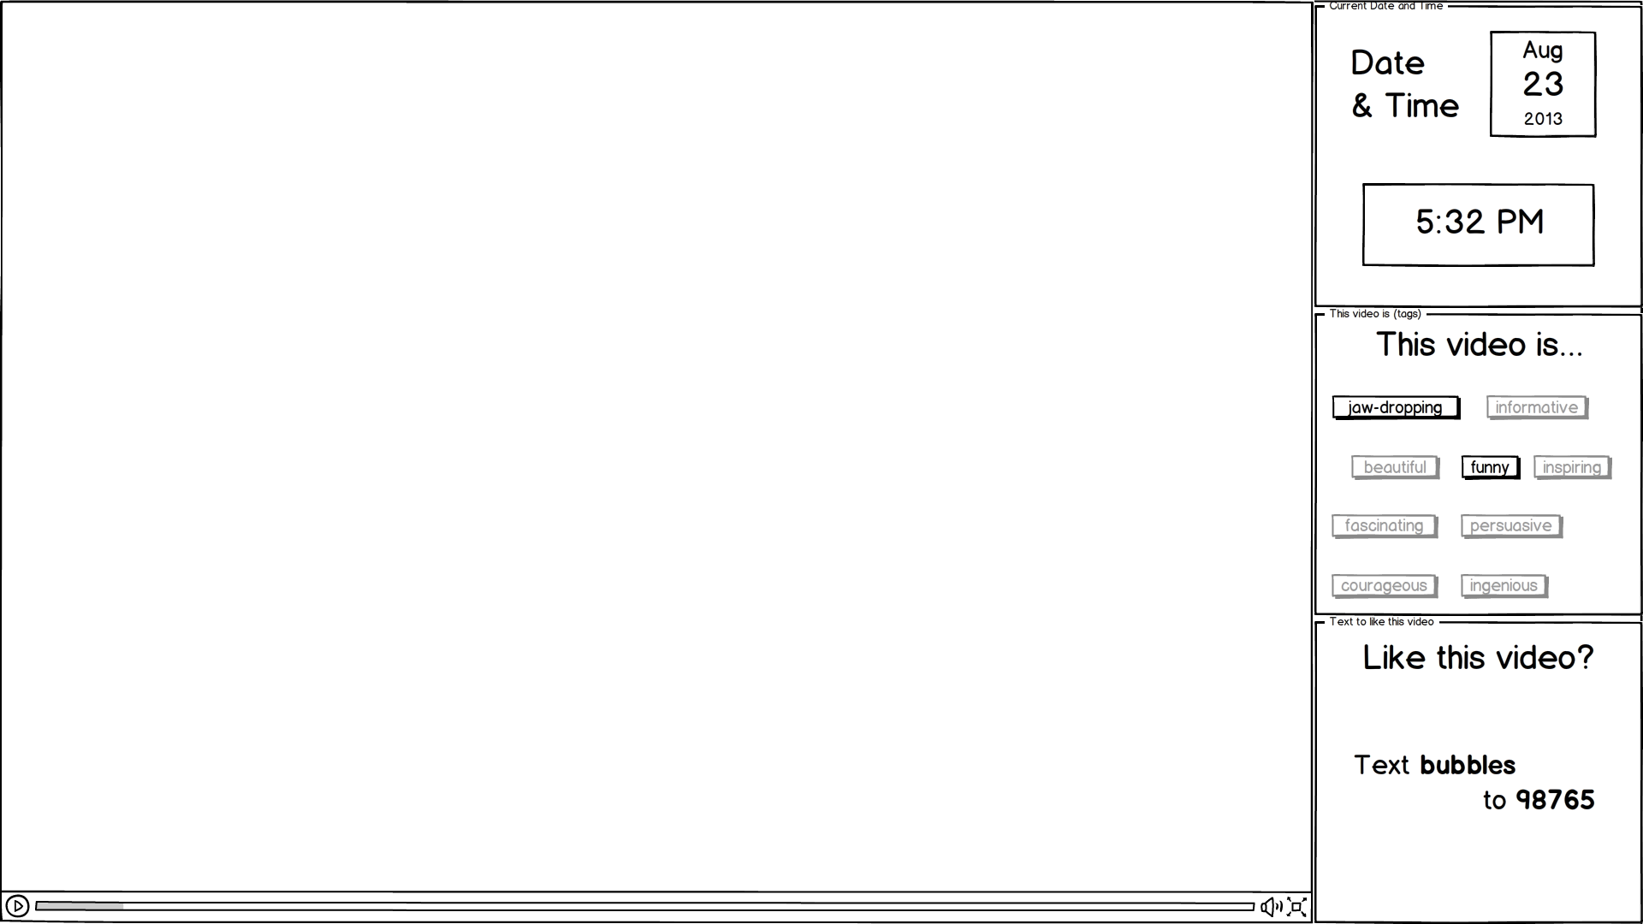
The dashboard will allow space for three square shaped widgets on the right side. A widget can take up the space of one to three of the squares. The selected widgets can be changed while the channel is playing.

Date & Time widget
The “Date & Time” widget will display the current date and time.

Weather widget
The “Weather” widget will display information on the local weather, such as the current temperature and weather conditions.

Tags widget
The “Tags” widget will display all possible tags, highlighting the tags that are applicable to the video that is currently playing.

Like widget
The “Like” widget will display the like phrase for the video, which will be used for providing feedback on the video. More information on the functionality for providing feedback is available in Section 2.10.

Description widget
The “Description” widget will provide a brief description of the current video. The widget will use the YouTube video title as the description or will use the title override if one is provided for the video.

YouTube Videos
The REITube player will only play videos that are stored on YouTube. To include new videos in the playlist, such as videos produced by REI, these videos will first need to be uploaded to YouTube and then added to the REITube playlist.
The laptop playing the video will not be signed into a YouTube account. All videos played by the laptop must be public or unlisted.

Video Queue
The dashboard will automatically play videos, one after another.
Each video stored in the system will belong to one of the five weekdays. The system will order videos by how recently they have been viewed, with the most recent videos stored at the bottom of the list.
To select a video to play, the system will use the following steps:
- The system will choose the videos for the selected day.
- From these videos, the system will select the top half of the list (the videos that have been the least most recently watched).
- The system will randomly select one of the videos and play that video.
- Once the video has finished playing, the system will repeat the first three steps.

Access
The YouTube channel that is used for the REITube will only be accessed by the laptops that are used to display REITube on the TVs. The URL for the YouTube channel will not be provided to employees as the team does not want to encourage employees to look at YouTube videos on their own laptops when they should be working.

Stored Metadata
Relevant metadata will be stored for each video. The list of metadata that will be stored by the system is listed in Table 1: REITube Metadata.
Table 1: REITube Metadata
Field Name | Notes | Required?
ID | The 11 character YouTube ID for the video | Yes
Start Time | Used for trimming. | No
End Time | Used for trimming. | No
Volume | Value of 0 to 100 | No
Tags | The video must have one or more tags. | Yes
Title override | Alternate title text | No
Like phrase | Short word used to uniquely identify the video | Yes

Video Trimming
If we have defined a start time for the video for the video, the video will begin playing at the specified start time rather than playing from the beginning. If there was no start time specified, the video will start playing at the beginning.
If we have defined an end time for the video, the video will stop playing at the specified end time rather than playing to the end. If there was no end time specified, the video will continue to play to the end.
This functionality will allow the system to cut out unwanted portions of the video at the beginning and the end, such as cutting out a slow start or removing subscription information at the end of a video.

Volume levels
If a volume level is set for a video, that volume level will be used instead of the default volume.

Tagging
Each video will have one or more tags specified. The tags will help to provide some basic information on the type of video and to give an idea of why we are showing the video.
We will use the following tags:
- Jaw-dropping
- Persuasive
- Courageous
- Ingenious
- Fascinating
- Inspiring
- Beautiful
- Funny
- Informative

Liking videos and feedback
The “Like” widget on the dashboard will provide a unique word to identify the video.
A ballot box will be placed near the TV for employees to indicate the videos they like. A pencil and little ballots will be placed with the box. The ballots will have a space to indicate that the “like” phrase should be written on the ballot.
The ballot box will allow the team to collect feedback on which videos are popular and will give the employees an opportunity to engage the REITube.
We will also provide an email address for people to provide additional feedback.

PROCESS

Submission Process
Initially, videos will be submitted, primarily by the team, over email either directly to Christian or to a special email set up for the REITube.
All submitted videos should fit the following criteria:
- On YouTube
- Appropriate for work and not offensive
- Entertaining to a broad audience
- Applicable to one or more of the defined tags
- Video quality suitable for the large TVs
- Decent sound quality (videos that can be viewed without sound are ideal for the 2nd floor atrium TV)
- Not extremely long

People can submit either the URL to the video or just the YouTube ID for the video.

Review Process
A moderator will review all submitted videos before being adding the videos to the playlist.
A good moderator will ensure that each video meets the qualifications listed in the previous section.

FUTURE ENHANCEMENTS
Table 2: Future Enhancements lists all of the potential enhancements that the team has proposed doing at a future time.
Table 2: Future Enhancements
# | Description
1 | Crowd source submissions and reviews. Provide a way to allow anybody in the company to easily add new videos to the queue and a way for these new submissions to be easily reviewed by more people.
2 | Give an electronic method for people to vote videos up and down.
3 | Add an algorithm to the playlist that will play longer videos during lunch time and shorter videos at other times.
4

TABLED IDEAS
This section documents ideas that were proposed but will not be implemented for this project. The purpose of this section is to document the reasons for why the team has decided not to implement certain ideas, in case the ideas are proposed again in the future.
Appendix Table 1: Table of Tabled Ideas
# | Idea | Reason for rejection
1 | Allow users to provide feedback using text messages. Ex: “Text BUBBLES to 1234 to like this video”. | Not everybody has unlimited texting. Our method of feedback should be inclusive
2
3
4
5
6
7

